**Game Introduction**

CSGO is a multiplayer FPS where Terrorists (T’s) need to plant a bomb in one of the two bombsites and Anti-terrorists (CT’s) must defend them; defusing the bomb if required. Moreover, there is an economy that varies in each 2 min. round (best of 30) and heavy use of utility (grenades) is key.

As the prime example of the tactical FPS sub-genre, CSGO’s level design focuses heavily on concepts including, but not limited to: *L.O.F*1, *bombsites3*’ timings, grenades’ areas of effect, visibility, predicting the opponents’ placings and intentions, *etc*.

**Level Design Principles**

**1. L.O.S Exposure**

Most of the time, players either hold an angle (that is to say, they aim at a crucial spot from a certain position) or they *peek*4.

When peeking, players expose themselves; CSGO’s maps are specifically designed to make players exposed if they decide to take risks, let it be by *peeking, rushing*5 into the open, etc.

These actions, thus, can leave the player in two possible scenarios, after being exposed:

1. There is only one *L.O.F*  that can be traced from allies to enemies
2. There is more than one *L.O.F* from allies to enemies. In this case, enemy threats can be categorized in primary and secondary threats, depending on distance, position, quantity...

By being aware of this information, CSGO players can use angles to their advantage. Preferably, a single threat is to be targeted from a spot. That is to say, the ally must position their model in a spot that cannot be targeted at the same time from another enemy threat.

Said pretext, though, is virtually impossible, since the game’s map areas force players to be exposed to secondary threads even if they try to target a singular, main threat.

Usually, if there is a need to address threats simultaneously, players end up micro-managinga small area, switching between covers (and targets, when required).

1*L.O.F*: *Line Of Fire*, an hypothetical projection from one player’s *crosshair*2to an enemy that is not intercepted by map geometry, for a given position and rotation

2*crosshair*: visual indicator to help aim at a target

3*bombsite*: region that contains a specific area where the bomb can be planted.

4*peek*: quickly stop hiding in cover to take an aim duel.



5*rush*: venture into a key spot in a fast and aggressive manner, often exposing yourself.

In the following example, a terrorist is entering *bombsite A* in the popular map *Mirage.* From this spot, though, there are 3 main *L.O.F’s* with singular enemy threats.

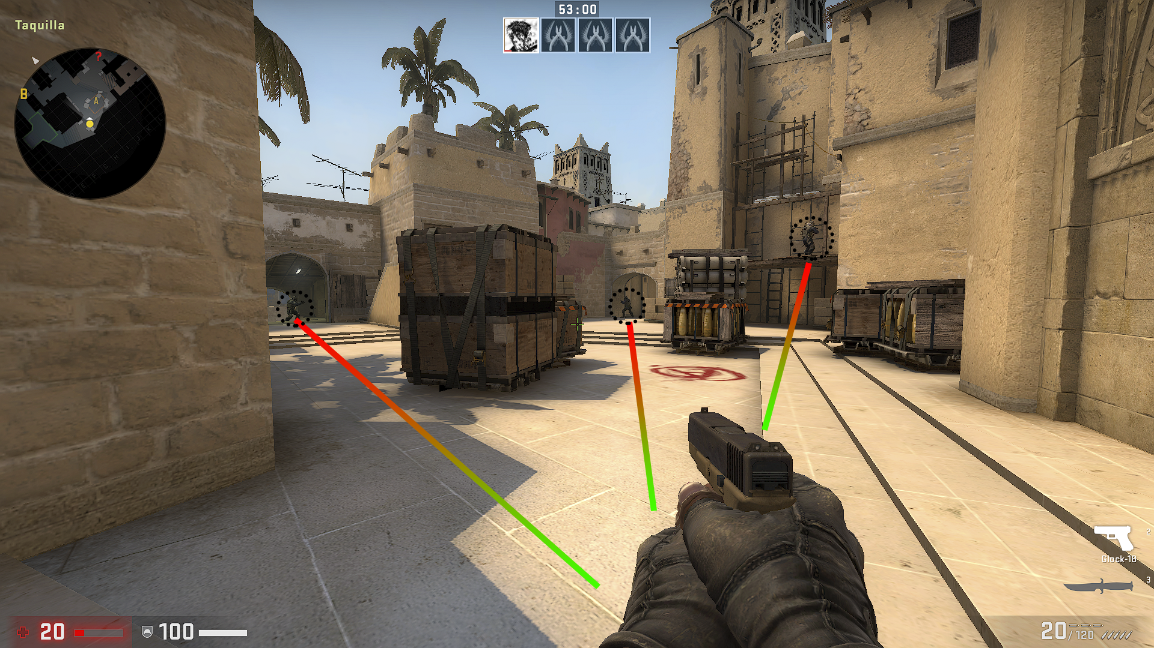

For simplicity purposes, let us assume both that this player is alone on a 1vs3 against the CT’s and that there is an urge to fight them to accomplish a bomb plant, barely on time.

Instead of choosing the position represented above, the player should use nearby covers and be aware of the potential *L.O.F’s*, in order to kill enemies one at a time:

1. Playing close to the left wall is an option that would grant cover from the left and the front threats, while giving access to the enemy on the right.
2. Going straight into the bombsite and playing around the boxes would be the most aggressive approach.
3. Playing close to the right wall can grant cover from the left and the front thread while making it awkward for the remaining.

The chosen approach, though, is irrelevant, since either way the ally is going to be exposed and keeping track of the moving opponents is an otherworldly task.

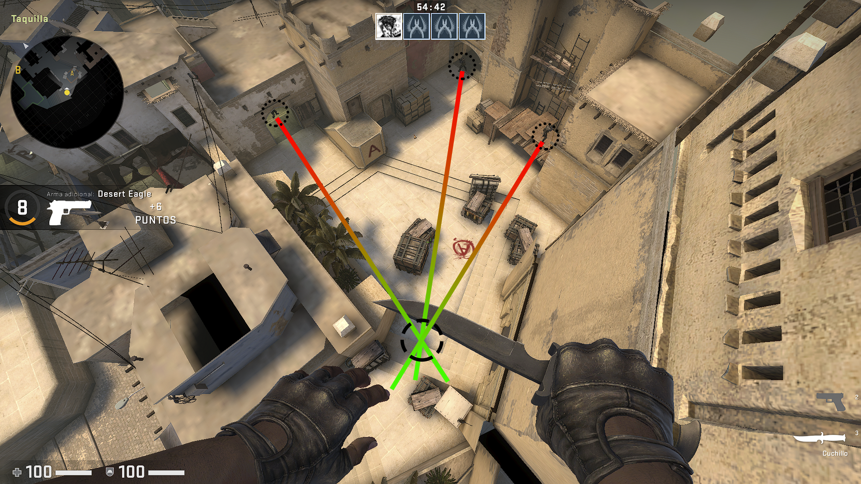

*An elevated view of the same situation*

Another example showcases how picking the right angle to play with is not obvious whatsoever. Again, 3 threats appear in the *F.O.V*1 and a lightning decision has to be made based on these spatial factors (apart from other mechanical and gameplay ones):

1. Proximity to the threat
2. Exposure to secondary threats if targeting a specific primary one
3. How much would the crosshair have to travel to reach a certain enemy from the current crosshair placement. That is to say, the angle between the facing direction and the direction to the thread

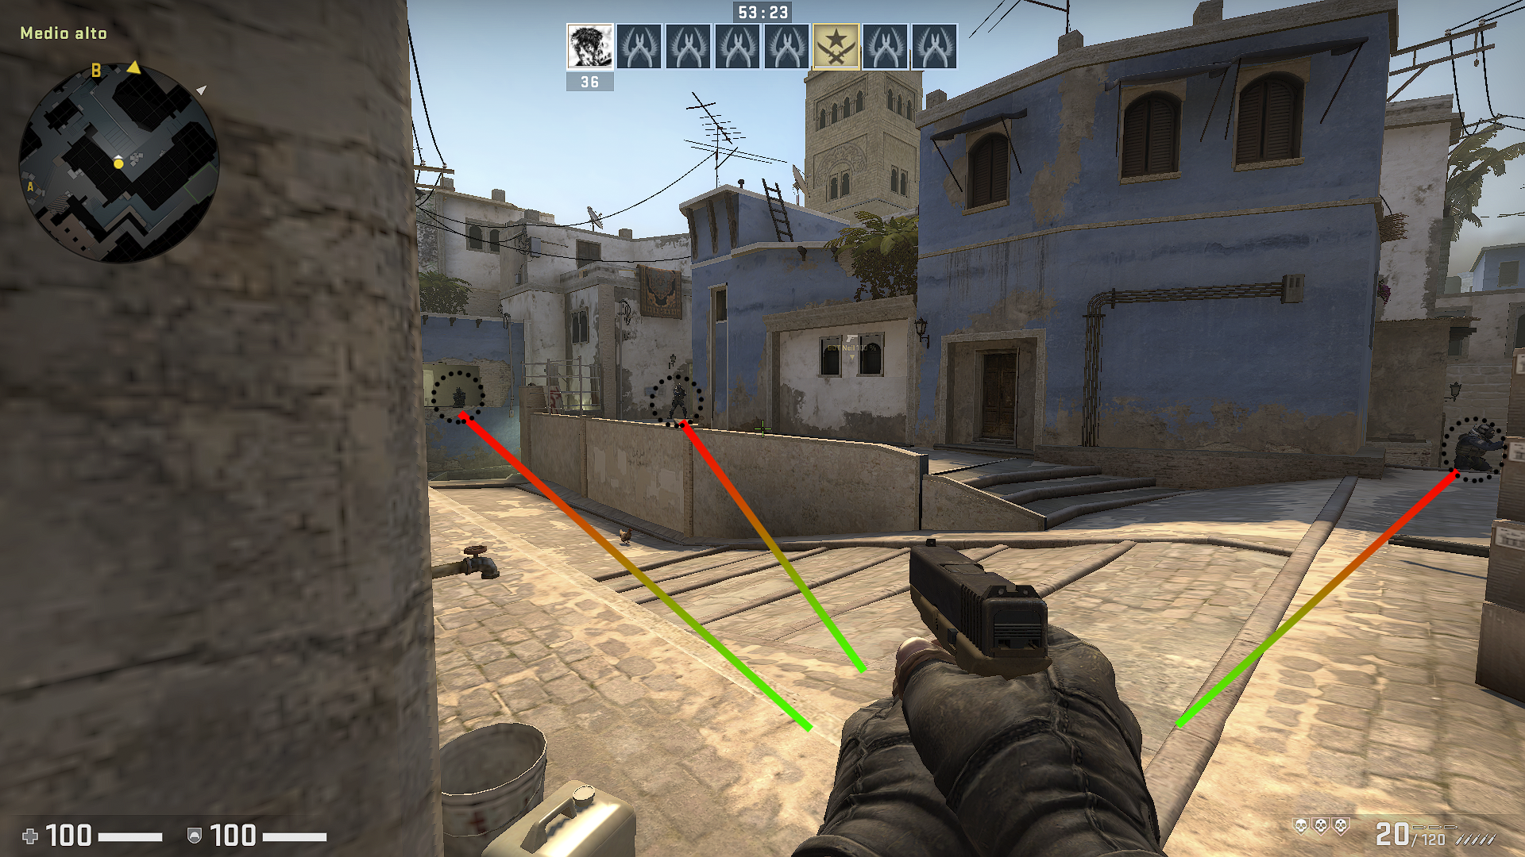

1*F.O.V*: *Field Of View*, or what a certain camera view sees.

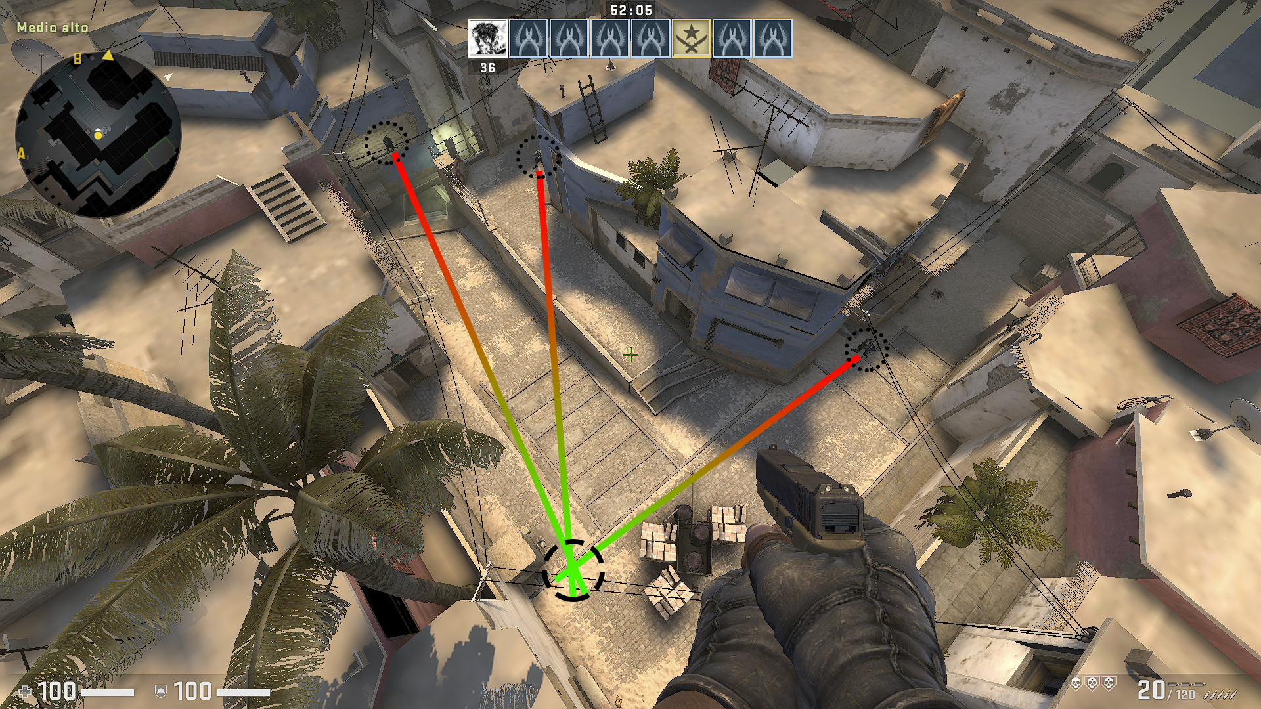

*An elevated view of the same situation*

// TODO

talk about height lof and about covers, eg cover height (fullbody from head to toe), what it brings to level design and overall what is the takeaway from this section (further one compare it to games of the same sub-genre and to other sub-genres)